# Google Search Engine Lookalike

### A MINI PROJECT REPORT

#### Submitted by

#### Group/Team No: 22/T10

**Dipankar Sethi, 2210990287**

**Dipanshu Saini, 2210990288**

**Divanshu Garg, 2210990289**

**Divanshu Kaushik, 2210990290**

#### in partial fulfillment for the award of the degree of

## BACHELEOR OF ENGINEERING

***in***

COMPUTER SCIENCE & ENGINEERING



**CHITKARA UNIVERSITY**

**CHANDIGARH-PATIALA NATIONAL HIGHWAY**

**RAJPURA (PATIALA) PUNJAB-140401 (INDIA)**

##### May2023

###### TABLE OF CONTENTS

|  |  |  |
| --- | --- | --- |
| Sr.no | Section | Page no |
| 1 | Introduction | 3 |
| 2 | Problem Statement | 3 |
| 3 | Technical Details | 3-6 |
| 4 | Key Features | 7 |
| 5 | Project Advantages | 7 |
| 6 | Result | 7 |
| 7 | Conclusion with Future Scope | 8 |
| 8 | Sources And References | 8 |

1. **Introduction**

Google is an American multinational technology company that specializes in internet related services and products. The company was founded in September 1998 by Larry Page and Sergey Brin while they were Ph.D. students at Stanford University. Originally, Google was a research project that aimed to develop a search engine that could deliver more accurate and relevant search results than existing search engines. Today, Google is one of the largest and most valuable companies in the world, with a wide range of products and services that includes search engines, online advertising technologies, cloud computing, software, and hardware. The company's flagship product is the Google search engine, which is used by billions of people around the world to find information on the internet .Google has been known for its innovative approach to business and its commitment to user satisfaction. The company's mission statement is "to organize the world's information and make it universally accessible and useful." Google has consistently pushed the boundaries of what is possible with technology, introducing new products and services that have changed the way people live and work. As a result, Google has become a symbol of innovation and technological progress, inspiring countless entrepreneurs and businesses around the world. So, we created this Google Search Engine Lookalike having a user friendly interface and easy to use.

1. **Problem Statement**

Built a Google Search Engine Lookalike with required HTML, CSS and JavaScript

1. **Technical Details**

**HTML**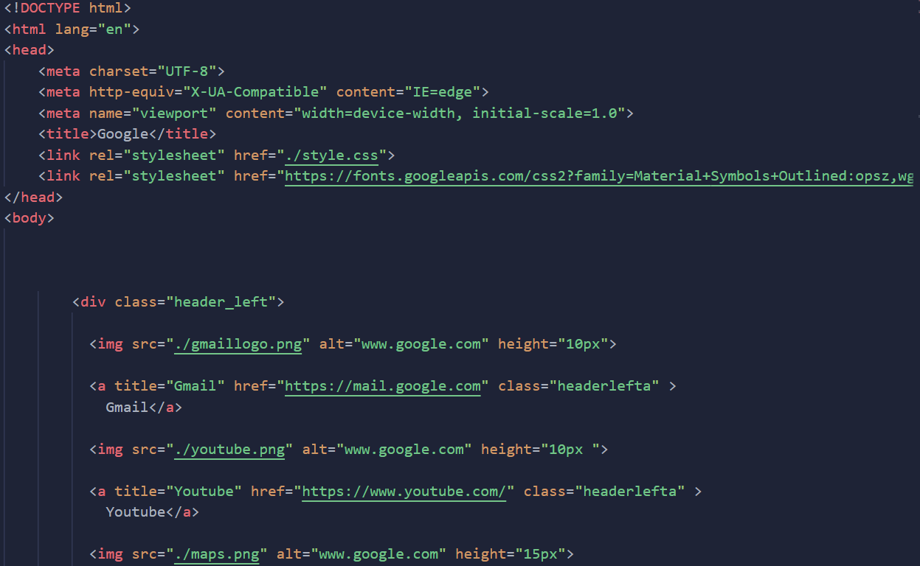

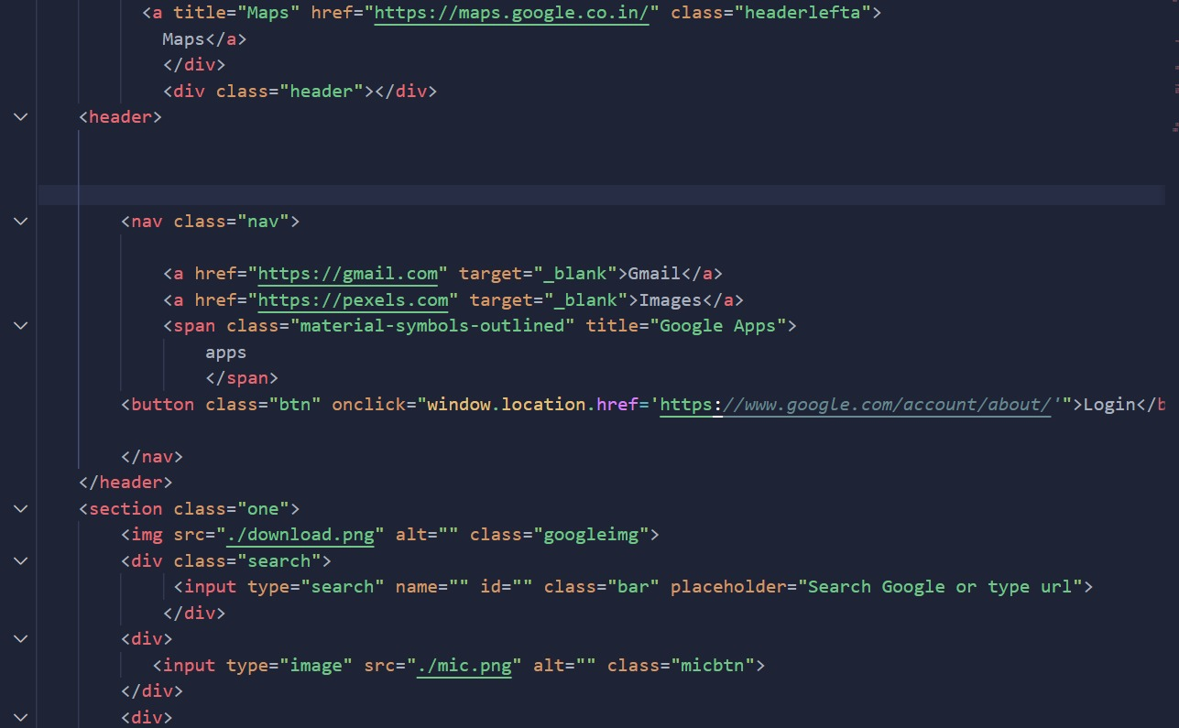

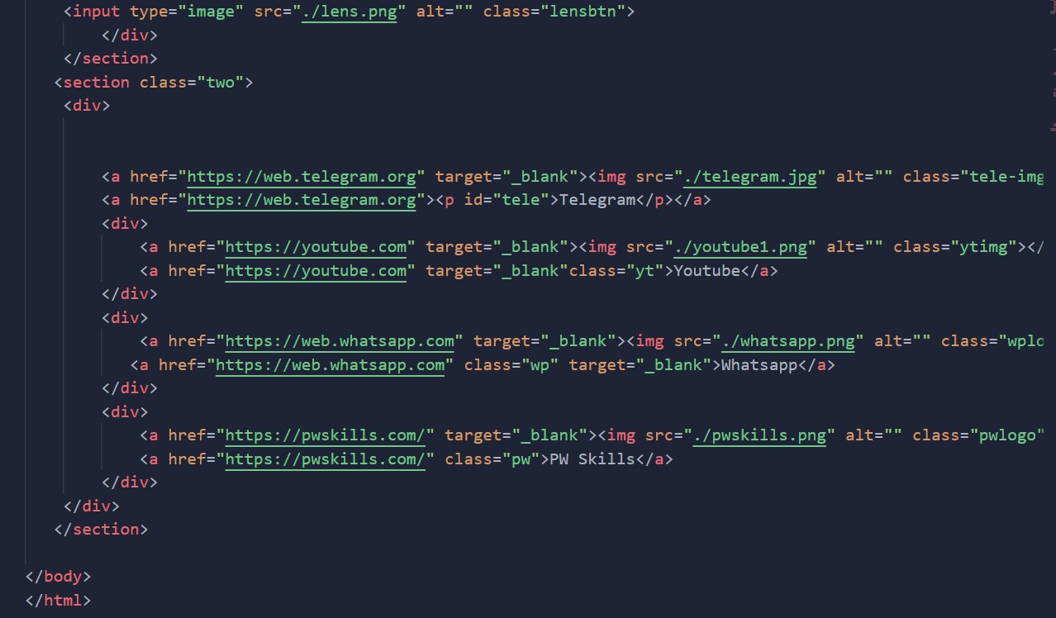

**CSS**

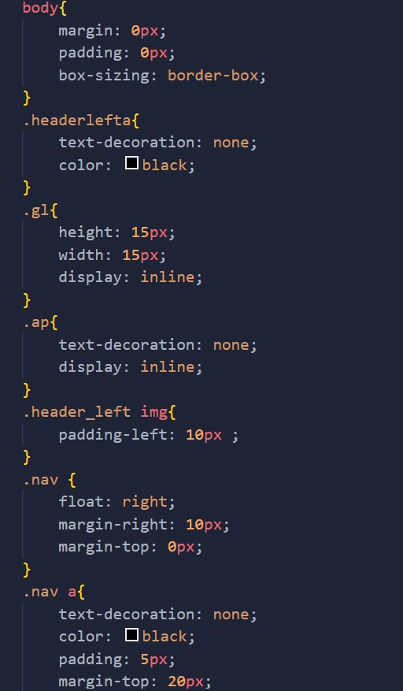

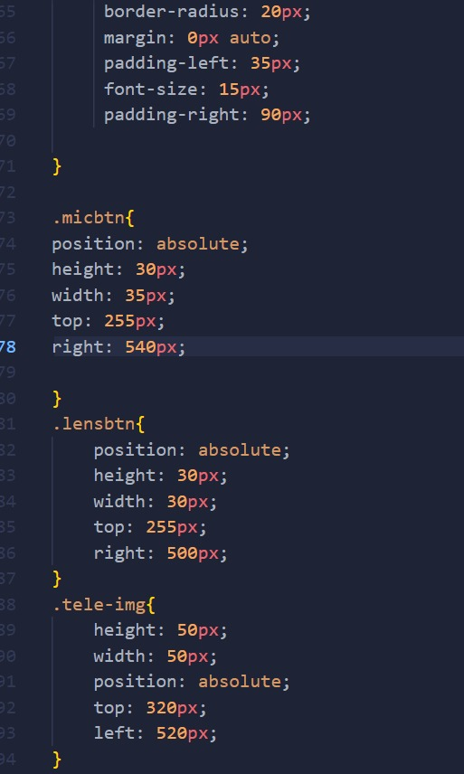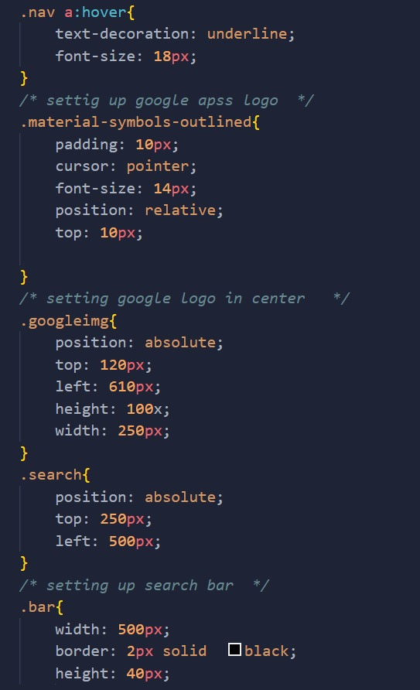

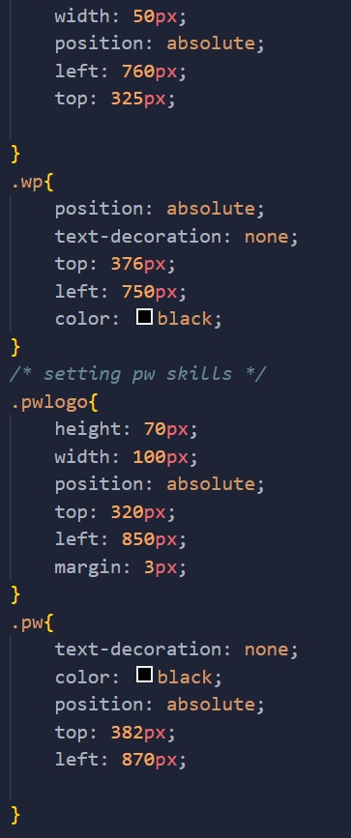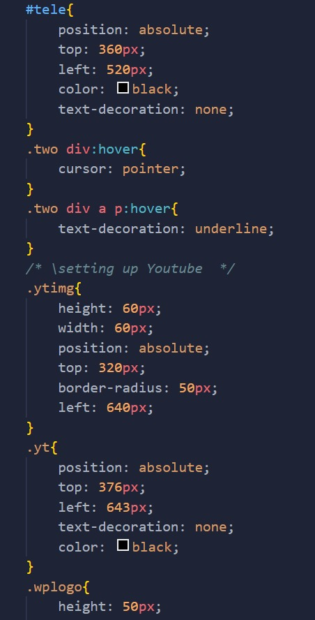

**JavaScript**

JavaScript is a dynamic programming language that's used for web development, in web applications, for game development, and lots more. It allows you to implement dynamic features on web pages that cannot be done with only HTML and CSS.

## What Would the Web Look Like Without JavaScript?

Without JavaScript, all you would have on the web would be HTML and CSS. These alone limit you to a few web page implementations. 90% (if not more) of your webpages would be static, and you'd only have the dynamic changes like animations that CSS provides.

**4.Key Features**

* A search bar where users can enter their search terms
* A list of results that are displayed based on the user’s search terms.
* Interactive and working buttons
* All Google features are added

**5. Project Advantages**

* Most reliable and simplest way to search anything.
* Major apps are added at front so that these can be used easily.
* Get fast results of the queries.

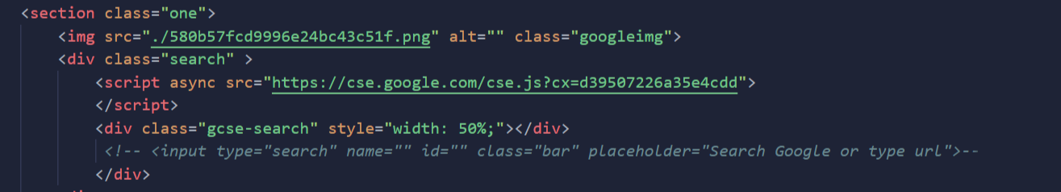

**6. Result**

Here is our Google Search Engine Lookalike have a search bar and some bookmarks and easy access to google maps and youtube. There are Shortcuts of different software below search bar. We can search using search Bar below the google icon . It will display all the related results related to your search. Also added a background to give it a cool look. Merged JavaScript with HTML and CSS.

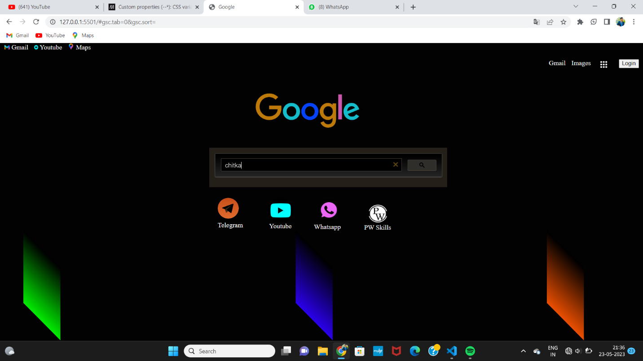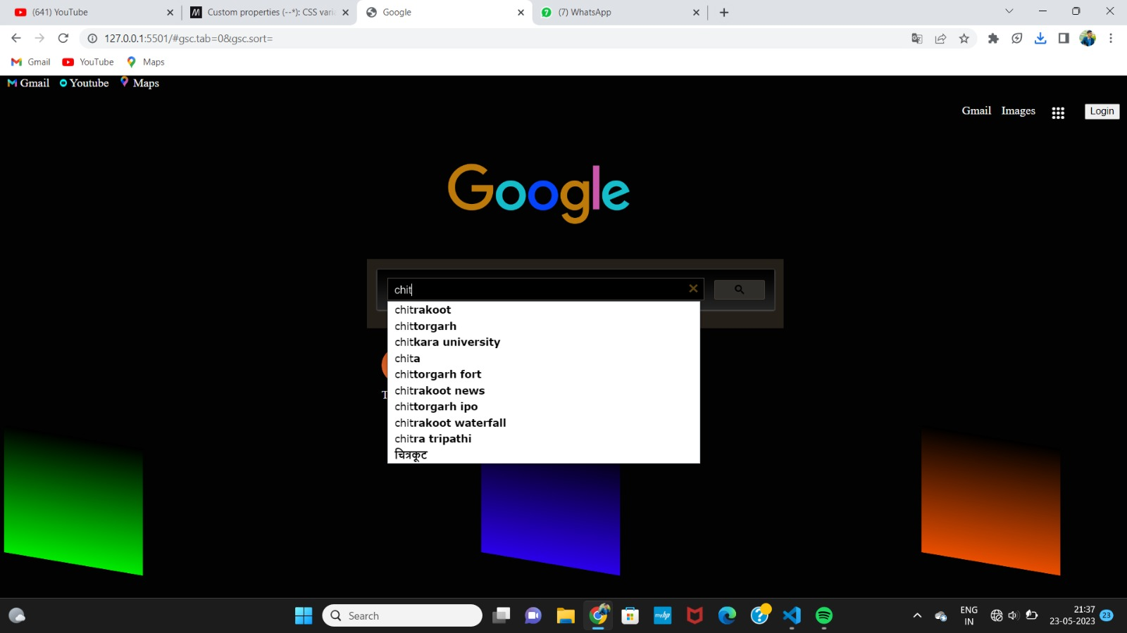

**7. Conclusion with Future Scope**

We have built a user interface for Google Search Engine with a aim to make it more user friendly with more features and with more optimization more accurate search results with in less time and several button are added in our project. We have merged HTML,CSS and JavaScript to make our project more optimized. For further development we are learning HTML,CSS and JavaScript in more depth and details.

**8. Sources and References:**

**In developing our Google Search Engine project, we referenced several sources and tools.**

**These include:**

**1. W3schools (https://www.w3schools.com/): A website that is popular online learning platform that offers a variety of tutorials and resources for learning HTML,CSS and other web development technologies.**

**2. Stack Overflow (https://stackoverflow.com/): A popular online community for programmers to ask and answer technical questions related to programming.**

**3. Google Fonts(**[**https://fonts.google.com/**](https://fonts.google.com/)**): A website that provides a wide variety of fonts for use in web design.**